National Enterprise Awards 2017
Application Form
(Strictly Confidential)
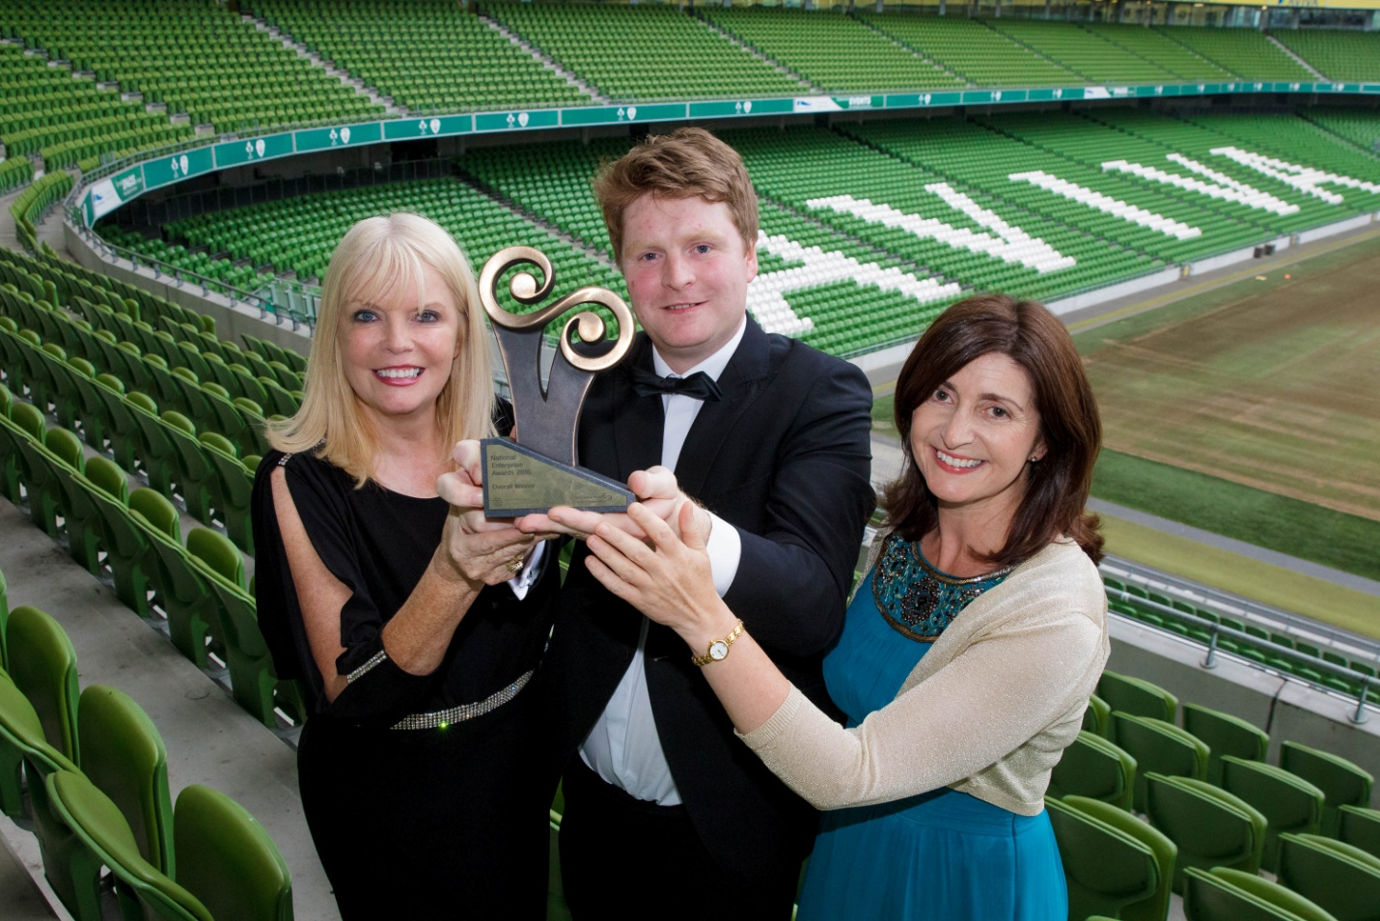
NEA Winner 2016 – Applied Concepts Ltd. – Offaly
Please return your completed application form, together with a current Business Plan, sample of marketing material and financial statements to Local Enterprise Office Offaly, Offaly County Council, Áras an Chontae, Charleville Road, Tullamore by close of business on Thursday, 16th February 2017.

GENERAL INFORMATION
Name of Applicant: __________________________________________
Business Name: __________________________________________
Address: __________________________________________
__________________________________________
Region: __________________________________________
Legal Status: (Tick one) Sole Trader Partnership Limited Company
Date of Commencement of Business: _________________________ ______
Phone. : _______________________ Business ______________________ (Mob)
Website : _____________________ e- mail:____________________________

Business Information
What product or service do you supply?

Describe your own background and why you set up in business?

What do you see as the key strengths of your business?

In what way and when, did your Local Enterprise Office help you (formerly CEB)? (Please include the year, type and level of support i.e. Grant aid and /or Training Supports)

Has this business been grant aided by any other government agency such as Enterprise Ireland, An Bord Bia, Leader Partnership, Inter Trade etc . (If so give details i.e. Agency, Year, Grant Amount, Type etc)

Marketing Your Business
Describe what is different or innovative about your product or service?

Is your customer base local, regional, national, international? Please give details.

How do you market your business?

Are there potential new markets for your business and how do you plan to take advantage of these opportunities?

Social Media
What forms of social media do you use to promote your business and describe any campaigns you have undertaken?

Technology
How do you use technology in your business?

The Future of your Business
What long-term plans do you have for your business and how do you see it growing and developing over the next 3 years?

What do you see as the key threats/weaknesses to your business? How do you propose to address them?

Employment Details
 | 31/12/2014 | 31/12/2015 | 31/12/2016 | Projected 2017
Full Time
Part Time

Financial Details
Business Growth | 2014 | 2015 | 2016
Annual Sales
Net Profit

Investment | 2014 | 2015 | 2016
Own Funds
Loans
Grants
TOTAL

Please return your completed application form, together with a current Business Plan, sample of marketing material and financial statements to Local Enterprise Office Offaly, Offaly County Council, Áras an Chontae, Charleville Road, Tullamore by close of business on Thursday, 16th February 2017.

Signed: _________________________________

Date: ____________________________________

Judges’ Marking Scheme for your information
(Not to be completed).
Business Plan | 20 | Total Marks
- Management capability / staff structure
- Competitiveness
- Growth potential
- Employment potential
- Business strategy
Marketing | 20
- Marketing strategy
- Company’s success in national and export markets
- Growth in sales revenue this year over previous years
- Responsiveness to market trends
Finance | 20
- Financial commitment of the owner
- Profitability of the company
- Strength of the balance sheet
- Net assets of the company

Technology & Innovation | 20
- Use of technology
- Innovation in business e.g. finance, production, marketing, HR etc.
Entrepreneurial Skills of Promoter | 20
- Leadership qualities
- Vision and drive
- Commitment
- Entrepreneurial capability (risk taking etc)

TOTAL (out of 100) ________

